1. Set your username and email in git config
2. Create a new branch named "feature-branch" and switch to it.
3. List all branches in the repository.
4. Delete the branch “feature-branch”

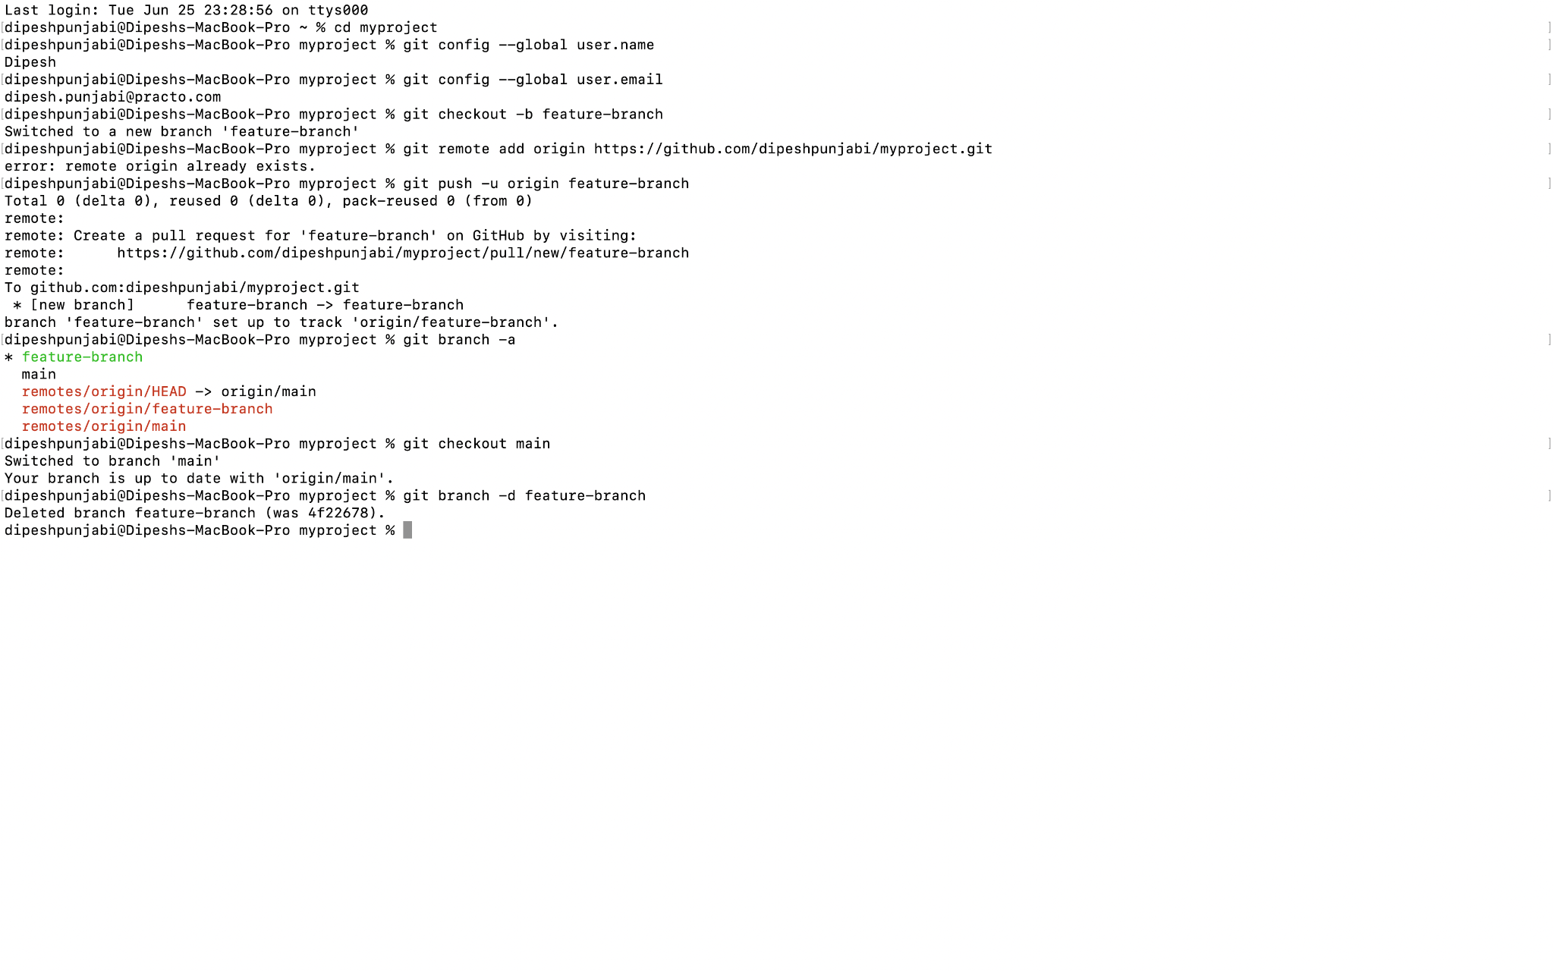

1. How do you undo the last commit

git reset HEAD^ [This will revert the staging area to match the HEAD commit]

1. Create a new branch names “conflict-branch”
2. Create a another branch named “feature1”
3. Make some changes in to feature1 branch
4. Merge “feature1” branch into main branch
5. Make changes in “conflict-branch”, in the same file and line that you had made changes in feature1
6. Merge master into conflict-branch [Attach screenshot of terminal & file]

Main is master branch

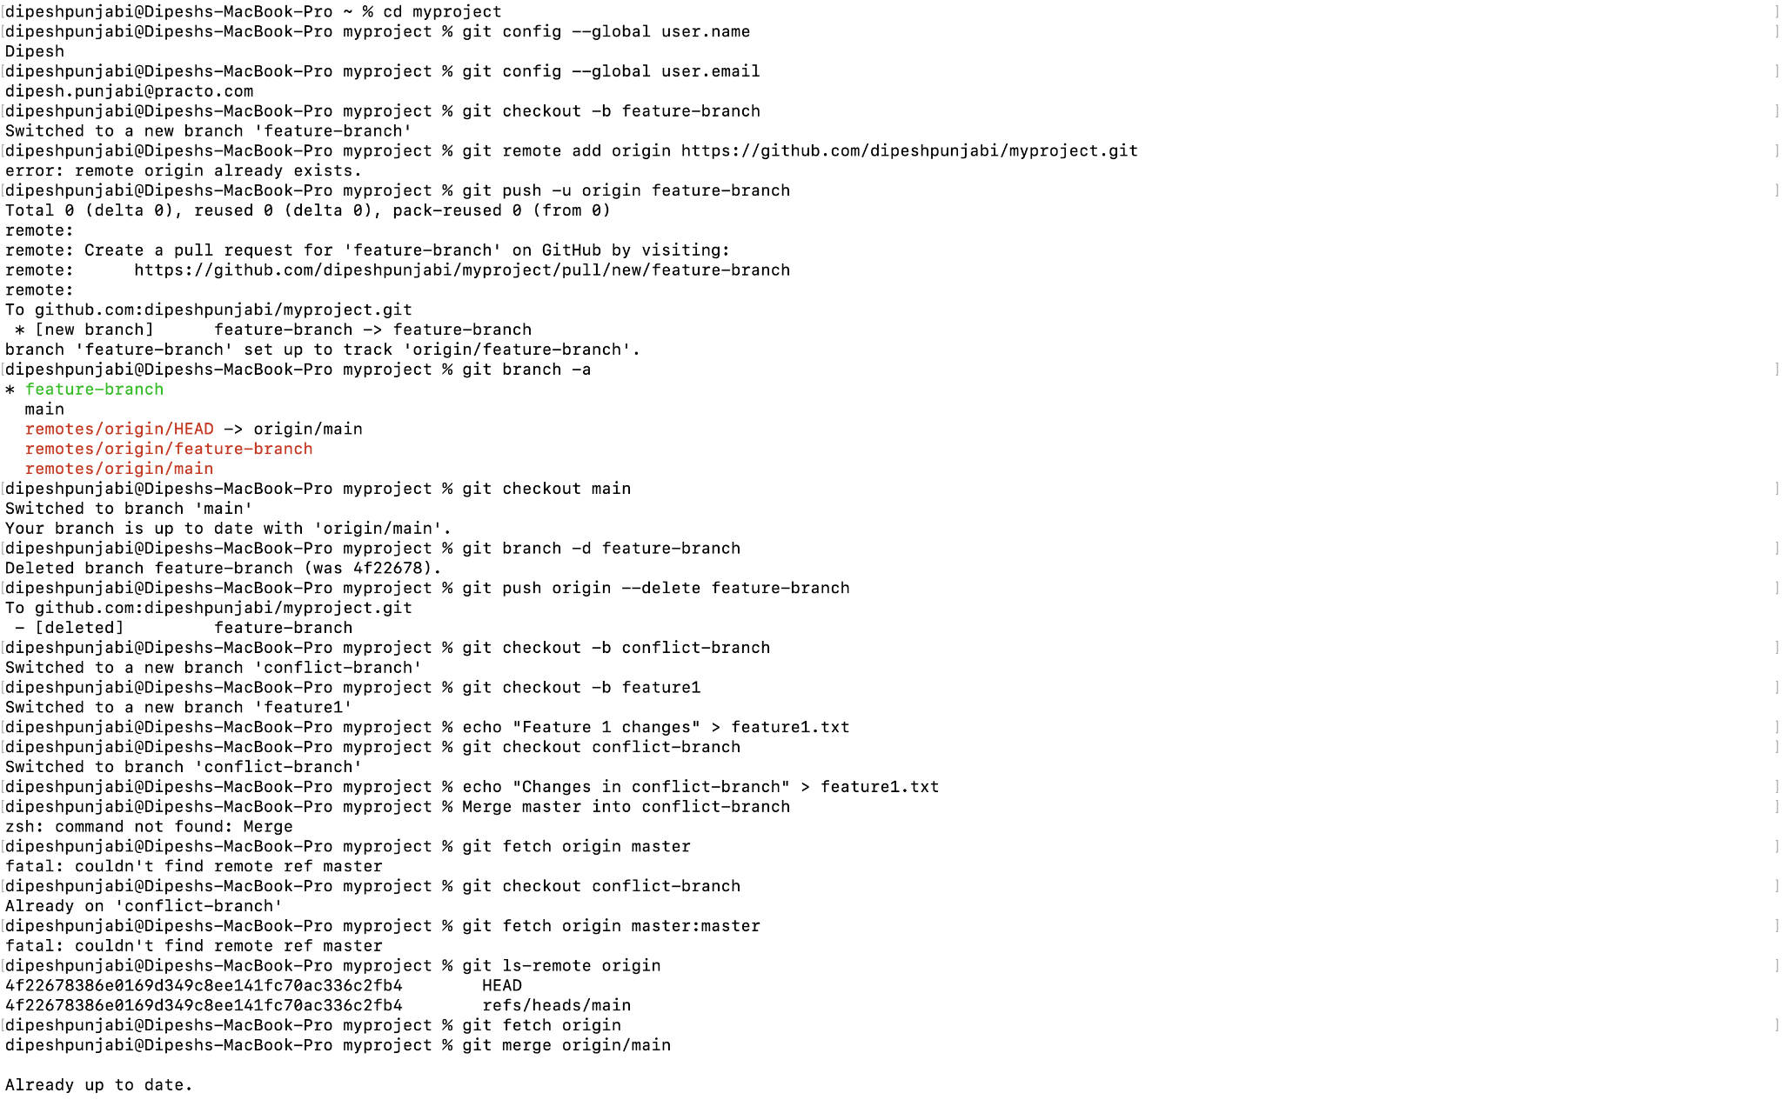

1. Resolve merge conflicts

Up to date.

1. Add a remote named "origin" pointing to a GitHub repository.
2. Fork a repository on GitHub and clone it to your local machine.
3. Create a new branch on your fork, make changes, and open a pull request to the original repository.

TRIED CREATING TWO BRANCHES AFTER CREATION, THERE WAS NO POP UP APPEARED SAYING I HAVE CREATED TWO BRANCHES AFTER THE PUSH OPERATION, BRACHES ARE SHOWING BUT NO POP UP

I did make some changes in a code of fork-repo

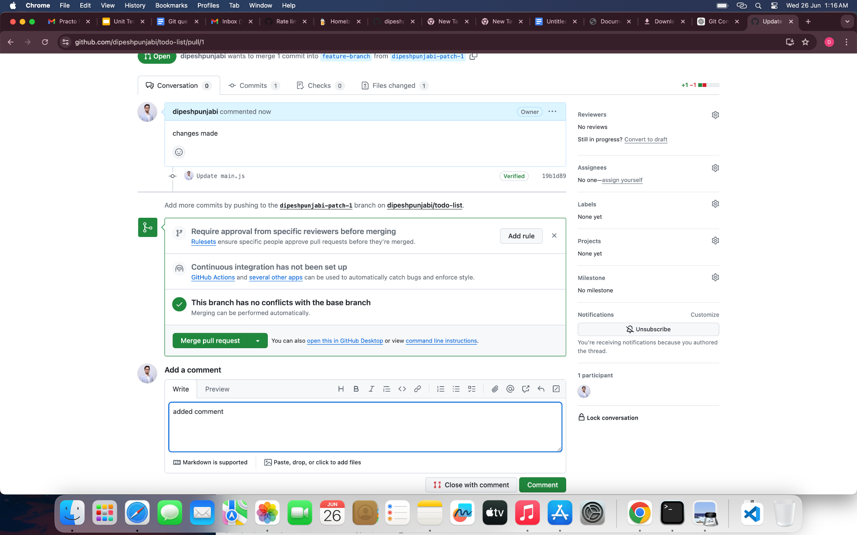

THIS WAS DONE, CHANGES MADE , AND A PULL REQUEST WAS CREATED AND ADDED A COMMENT

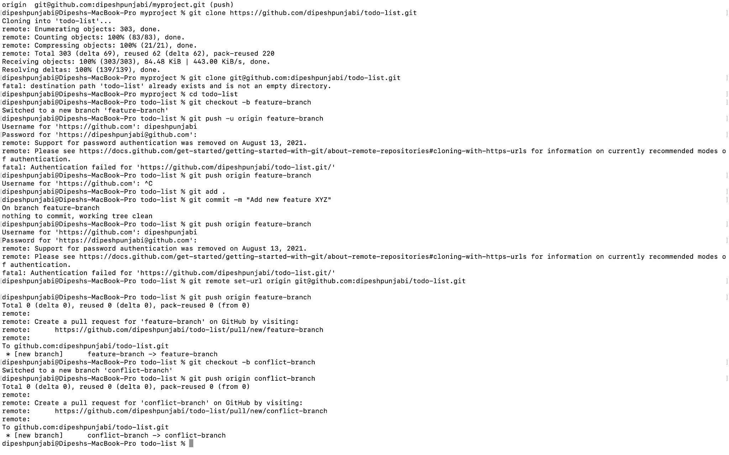

1. Comment on a PR and suggest improvements
2. Create a Git alias for the command `git log --oneline` named `gitlol`.
3. Create a pre-commit hook
4. You have made local changes in your branch, but you need to switch to another branch urgently without committing. How would you handle this situation?
5. You accidentally deleted a file in your local repository. How do you restore it using Git?

git checkout -- example.txt

1. You have committed changes to your branch but forgot to include a file. How do you add the file to the last commit without creating a new commit?

git add path/to/forgotten/file

git commit --amend [--no-edit]

git push --force

[if needed]

1. You want to discard all changes in your working directory and revert to the last commit. What Git command would you use?

git reset --hard HEAD

1. You need to view a specific commit's changes. What Git command can be used to show the changes introduced by a particular commit?

git show <commit>

1. You want to change a commit message, after you have already committed, how do you do so?

git commit --amend -m "New commit message"

1. Your colleague has made changes in their branch, and you want to incorporate those changes into your branch without merging. How do you achieve this?

git cherry-pick <commit>

1. You've made several commits on a branch, but you want to club them into a single commit before pushing to the remote repository. How would you do that?

git rebase -i HEAD~n

1. You accidentally staged a file that you don't want to commit. How do you unstage it?

git reset HEAD <file>

1. You don’t want to commit files that have .yml in the end, and also files inside folder config. How do you do that?

\*.yml # Ignore all files with .yml extension

/config #for entire config directory

1. You want to see a list of all the files changed in the last commit. What Git command would you use?

git show --name-only HEAD

1. You realize that your local branch is outdated, and you want to fetch the latest changes from the remote repository. How do you do this without merging?

git fetch origin

1. You accidentally deleted a branch. How do you recover it?

git reflog --no-abbrev

1. You want to remove untracked files and directories from your working directory. What Git command would you use?

git clean -df

1. You have a commit from a feature branch that you want to apply to the main branch without merging the entire feature branch.

git checkout main

git cherry-pick <commit>

1. You mistakenly committed a change to the wrong branch and need to apply that commit to the correct branch.

git log --oneline

git checkout correct-branch

git cherry-pick <commit>

1. There is a series of commits on a feature branch, but you only want to cherry-pick a specific range of commits.

git checkout main

git cherry-pick <start-commit>^..<end-commit>

1. You want to clone a GitHub repository onto your local machine, but you only need a specific branch. How can you achieve this?

git clone -b <branch-name> <repository-url>

1. You've made changes to your local repository and want to push them to your fork on GitHub. What Git commands would you use?

git push origin <branch-name>

1. You want to create a new branch both locally and on GitHub to work on a new feature. What commands would you use?

git checkout -b new-feature-branch

git push origin new-feature-branch

1. You want to see the commit history of a GitHub repository. How can you do this using Git commands?

git log --oneline

1. You've accidentally committed sensitive information and want to remove the commit from both your local and remote repositories on GitHub. What commands would you use?

git rebase -i HEAD~n

git push origin branch-name --force

1. You want to delete a remote branch on GitHub. What Git command would you use?

git push origin --delete <branch-name>

1. Create a git repository for all your assignments and upload them in it. Ask your peers to code review it, and you need to code review your peers assignments

git clone https://github.com/username/assignments-repo.git

cd assignments-repo

You can upload assignment and push

1. Create a pull request on any open source library on github, attach the pull request link to the readme file of this project’s repository

AFTER CLONING, ADDING A BRACH, PUSHING , PULL A REQUEST THEN DO THIS:

git add README.md

git commit -m "Added link to pull request"

git push origin feature-branch